Department of Computer Science and Engineering
Course Code:CSE430 | Credits: 1.5
Course Name: Digital Signal Processing (DSP) | Prerequisite:CSE111, MAT120
Lab 05
Z-Transform
- Lab Overview:
Learn MATLAB programming concepts for Z-Transform.

- Lesson Fit:
There is pre-requisite to this lab: CSE111, MAT120. You should have intensive Programming Knowledge and capability of understand Integral Calculus and Differential Equations.

- Acceptance and Evaluation
Performed lab tasks will be evaluated by the Lab Instructor (LI)
  - Short viva will be conducted in each Lab or occasionally to examine your work.
  - You may work in groups but be aware that you will be evaluated individually; hence active participation during the Lab work demonstration is recommended.
  - There will be Lab handout after your work you have to handover it to LI

- Learning Outcome:
After this Lab, the students will be able to:
  - Understand basic of Z-transform.

- Activity:
Z-transform:
The Z-transform of a discrete time signal x(n) is
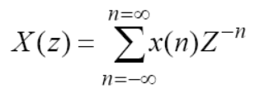
where, z is a complex variable. Since z-transform is an infinite series, it exists only for those values of z for which this series converges. The region of convergence (ROC) of X(z) is the set of all values of z for which X(z) attains a finite value.

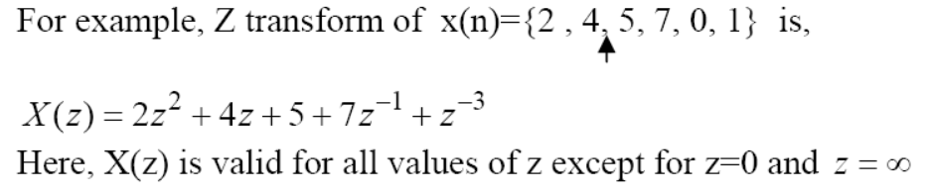
MATLAB uses the function ztrans( ) for finding the Z transform of a function. It evaluates signals of the form x[n]u[n], i.e. for non-negative values of n.

clc;
clear all;
close all;

syms n a x; %These will be treated as symbols
x= a^n;
ztrans(x) %Shows the Z-transform in terms of those symbols

The sym/syms command lets you construct symbolic variables and expressions.

Convolution property of Z transformation
Convolution in time domain is equivalent to multiplication in Z-domain
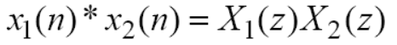
Prove the convolution property of Z transformation from the following:

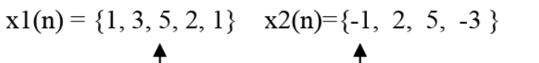
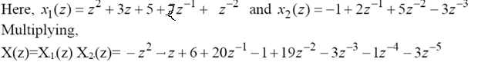
clc;
clear all;
close all;

x1=[1 3 5 2 1];
id1= [-2:2];

x2= [-1, 2, 5, -3];
id2=[0:3];

c = conv(x1,x2);
idc=(min(id1) + min(id2)):(max(id1)+max(id2));

stem(idc, c)
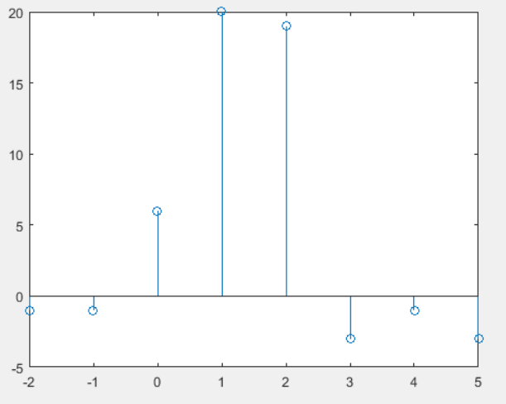

Inverse Z transform
The inverse Z-transform is the conversion of Z-domain signal into time domain signal. The inversion can be done by Cauchy’s Integral theorem, long division process, partial fraction expansion etc.

Partial Fraction
Suppose Y(z) is given in the time domain as,
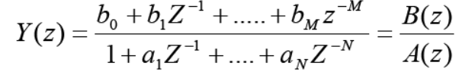
To convert it in time domain it is expressed as,
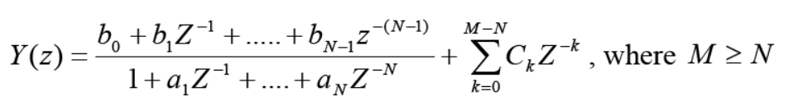
Then performing partial fraction expansion on the proper rational part of Y(z) to obtain,
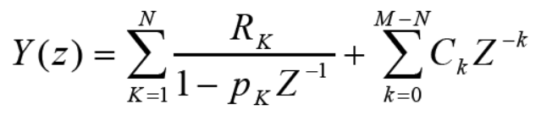

Matlab
A MATLAB function residuez( ) is available to compute the residue part and the direct terms. [R, p, C] = residuez(b,a) finds the residues, poles and direct terms of X(z) in which two polynomial B(z) and A(z) are given in two vectors b and a.

Determine the inverse Z transform of

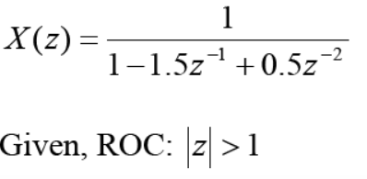

clc;
clear all;
close all;

b=[1];
a=[1 -1.5 0.5];

[Residues, poles, direct_terms] = residuez(b,a)
Residues = 2 -1
poles = 1.0000 0.5000
direct_terms = []

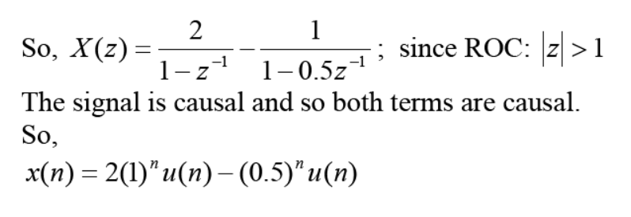
Impulse Response from Transfer function
If the system transfer function is available, the impulse response can be generated by MATLAB.
If the system transfer function is
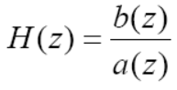
then the syntax for obtaining the impulse response using MATLAB is, [ h, t ] = impz(b,a,n)
where, n = Number of samples to compute.

The transfer function of a causal system is given by
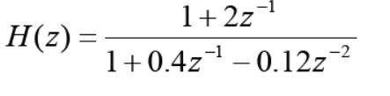
Determine the first 10 coefficients of the impulse response of this system.
clc;
clear all;
b=[1,2];
a=[1 0.4 -0.12];

n=10;

[h,t] = impz(b,a,n);

stem(t,h);
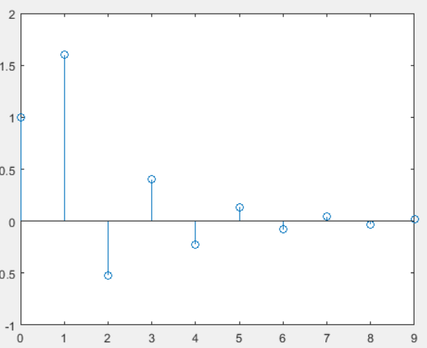

Pole Zero Plot
If a transfer function is given and you wish to obtain the poles and zeros of that transfer function by MATLAB use the function zplane ( ).

The transfer function of a causal system is given by
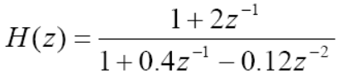
Find the poles and zeros of this transfer function.

clc;
clear all;
close all;
b=[1 2];
a=[1 0.4 -0.12];
zplane(b,a)
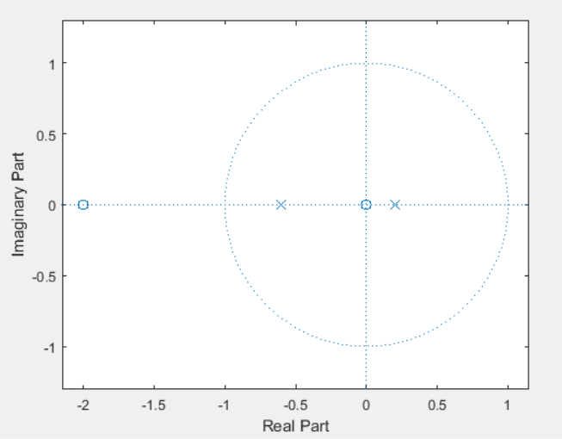

Pole Zero Cancellation for system stability
For a system to be stable all the poles of the transfer function must be inside the unit circle.

Test the stability of the following system.
Given, system transfer function,
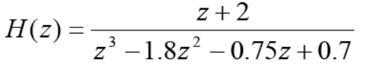
clc;
clear all;
close all;
b=[0 0 1 2];
a=[1 -1.8 -0.75 0.7];
n=15;

[h,t]=impz(b,a,n);

subplot(211), zplane(b,a), title('pole zero plot')

subplot(212), stem(t,h), xlabel('index'), title('impulse response')

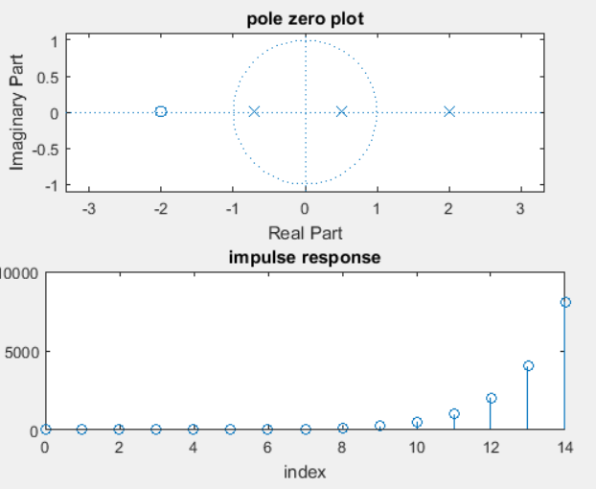

Activity List
Mark 10 Time: 45 minutes
Solve the following problems with MATLAB programming language

Question 1. Find the Z transform of x(n)=cos(ωn)u(n)
Question 2. What is the Z transform of the system described by the difference equation

Obtain the pole zero plot of the system transfer function. Also plot the impulse response. Is the system Stable? If the system is unstable, make it stable by cascading a second system with it.
UHints
Take Z transform on both sides of the difference equation, and obtain
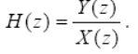

---END---

